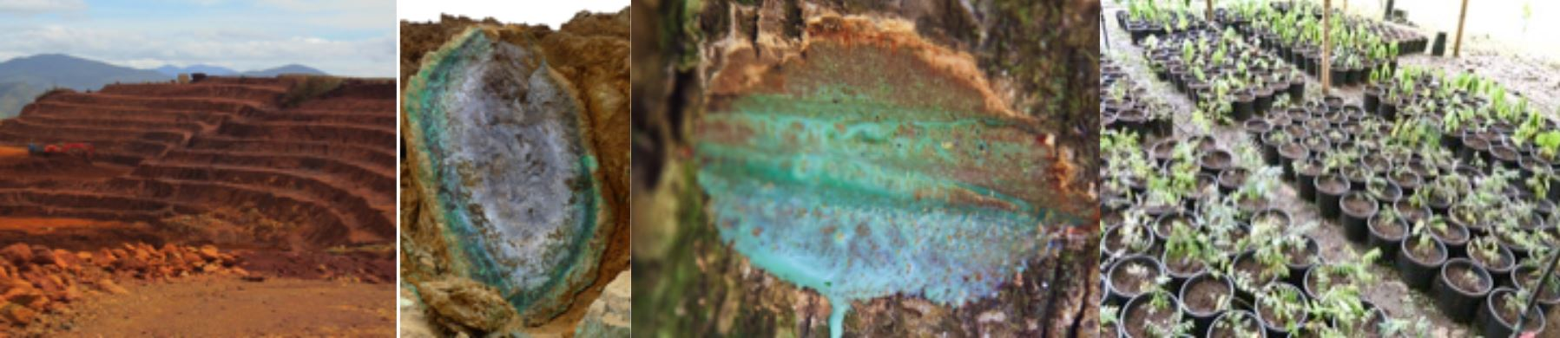
The registration to the workshop is free of charge. LabEx RESSOURCES21 and the Faculty of Sciences of the University of Lorraine are covering for the organisation of the Ni workshop.
Lunches are not included, but there are restaurants close to the workshop venue.
Two wine and cheese evening events will be held on October 17th and 18th, during the posters sessions.

To register, please fill in the following details:
Title
Given name
Family name
Email address
Institution
Department
Address
City
State/county (if any)
Postcode/ZIP
Country

Letter of invitation to attend the conference
A letter of invitation is issued solely for the purpose of assisting the participants in need of a visa application, and/or to obtain funding for their attendance to the conference. If you require a letter of invitation, please let us know when you register to the conference, sufficiently in advance.

All details for the venue will be sent at a later date to the participants.
The Ni workshop will take place over three days from October 17 to 19, 2017 in the Lorraine University (Faculty of Science, Amphitheater 8) on the Aiguillettes Campus, at Vandoeuvre-les-Nancy.
Vandoeuvre-les-Nancy is close to Nancy city and easy to reach from Nancy railway station by tram within 15 min.
Each participant will receive an abstract volume, as well as documents about the scientific activities by the Labex RESSOURCES21 and the Geosciences laboratories (OTELo) of Lorraine University.

• Organising Committee: Michel Cathelineau, Guillaume Echevarria, Lev Filipov, Christophe Cloquet, Laure Giamberini, Agnes Samper (GeoRessources, LIEC, CRPG, LSE from OSU OTELo, Vandoeuvre-les-Nancy, France)

