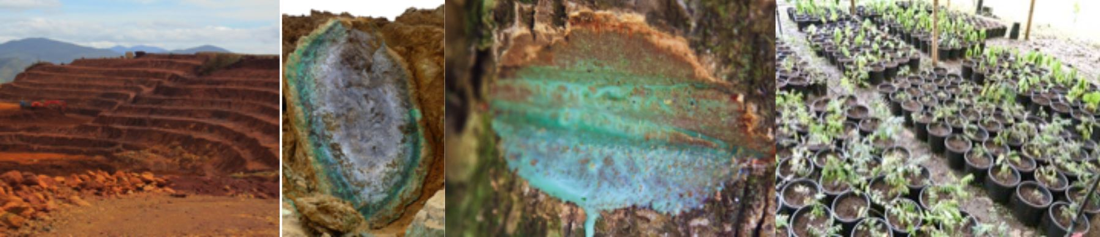
Title
First Author^{1*}, Second Author², Third Author^{1,2} (underline the presenting author)
¹First affiliation, address, city and postcode, country – (Use Arial Narrow 12 font)
²Second affiliation, address, city and postcode, country
*Corresponding author: E-mail address
Insert abstract text here.
Use Arial Narrow 14 font.
Paragraphs should be separated by a hard return.
The full abstract including title, affiliations and references should fit one page maximum.
Do not insert figures or tables.
The Laboratory of Excellence RESSOURCES21 and the Lorraine Earth and Environment observatory OTELO will host in Nancy, France, the 1st International Workshop on the geochemical cycle of nickel, on October 17 to 19, 2017.
example
This workshop is a call for transdisciplinary submissions. We aim at covering analytical advances in all topics related to low-temperature geochemistry of nickel and allied elements.
Through this conference, we wish to improve our understanding of key questions in the domain of Ni laterites from exploration to mining and processing:
• Ni mineralogy, including the behaviour of Ni during the serpentinisation and formation of Ni silicate ores (garnierite, talc-like, sepiolite)
• The geochemical cycle of elements allied to Ni: Sc, Mn, and Co
• Geometallurgy of Ni ores, including flottation and hydrometallurgy
• Ni in soils and plants : phytomining, agromining, including advances in Ni isotope geochemistry, Ni hyperaccumulators, remediation of soils on ultrabasic rocks
• Ni ecotoxicity and the hydrosphere….

References: (use the following style)
Cathelineau, M. et al. (2016) Miner. Dep. 51: 271
Golightly J.P. (1981) Econ. Geol., 75th anniversary volume 710-735
Name your file “lastname_oral.doc” or “lastname_poster.doc”. Send it to nickelworkshop-ressources21@univ-lorraine.fr and specify in your e-mail your preferred mode of presentation (oral or poster)

