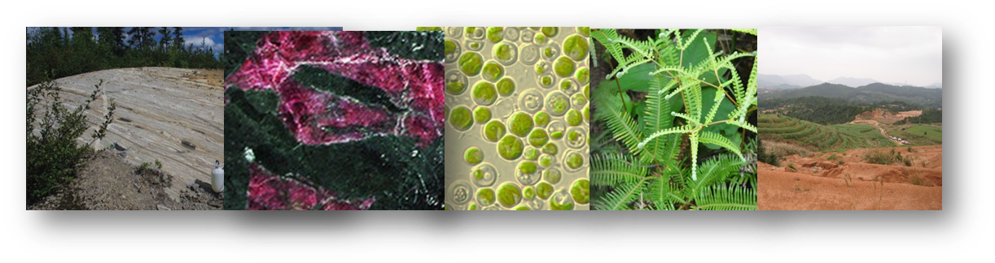
Abstract template

Title
First author^{1*}, second author², third author^{1,2} (underline the presenting author)

¹First affiliation, address, city and postcode, country – (use Arial Narrow 12 font)
²Second affiliation, address, city and postcode, country
*Corresponding author: e-mail address

Insert abstract text here.
Use Arial Narrow 14 font.
Paragraphs should be separated by a hard return.
The full abstract including title, affiliations and references should fit one page maximum.
Do not insert figures or tables.
LabEx R21 and the Lorraine Earth and Environment observatory OTELO will host the first international workshop on the geochemical cycle of nickel, in Nancy (France), on 8-10 October 2019.

References: (use the following style)
Cathelineau, M. et al. (2016) Miner. Dep. (2016) 51: 271
Golightly J.P. (1981) Econ. Geol., 75th anniversary volume 710-735

Name your file “lastname_oral.doc” or “lastname_poster.doc”. Send it to workshopREE-RESSOURCES21-contact@univ-lorraine.fr and specify your preferred mode of presentation (oral or poster) in your e-mail.

